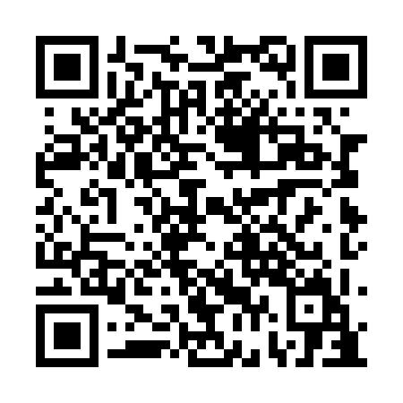
Ramadan times for Tour-Maher, Quebec, Canada
Mon 11 Mar 2024 - Wed 10 Apr 2024
High Latitude Method: Angle Based Rule
Prayer Calculation Method: Islamic Society of North America
Asar Calculation Method: Hanafi

Date | Day | Fajr | Suhur | Sunrise | Dhuhr | Asr | Iftar | Maghrib | Isha
11 | Mon | 5:25 | 5:25 | 6:53 | 12:42 | 4:38 | 6:32 | 6:32 | 7:59
12 | Tue | 5:23 | 5:23 | 6:50 | 12:41 | 4:40 | 6:33 | 6:33 | 8:01
13 | Wed | 5:21 | 5:21 | 6:48 | 12:41 | 4:41 | 6:35 | 6:35 | 8:02
14 | Thu | 5:19 | 5:19 | 6:46 | 12:41 | 4:42 | 6:36 | 6:36 | 8:04
15 | Fri | 5:16 | 5:16 | 6:44 | 12:41 | 4:44 | 6:38 | 6:38 | 8:06
16 | Sat | 5:14 | 5:14 | 6:42 | 12:40 | 4:45 | 6:39 | 6:39 | 8:07
17 | Sun | 5:12 | 5:12 | 6:40 | 12:40 | 4:46 | 6:41 | 6:41 | 8:09
18 | Mon | 5:10 | 5:10 | 6:38 | 12:40 | 4:47 | 6:43 | 6:43 | 8:11
19 | Tue | 5:07 | 5:07 | 6:36 | 12:39 | 4:49 | 6:44 | 6:44 | 8:12
20 | Wed | 5:05 | 5:05 | 6:33 | 12:39 | 4:50 | 6:46 | 6:46 | 8:14
21 | Thu | 5:03 | 5:03 | 6:31 | 12:39 | 4:51 | 6:47 | 6:47 | 8:16
22 | Fri | 5:00 | 5:00 | 6:29 | 12:38 | 4:52 | 6:49 | 6:49 | 8:18
23 | Sat | 4:58 | 4:58 | 6:27 | 12:38 | 4:53 | 6:50 | 6:50 | 8:19
24 | Sun | 4:56 | 4:56 | 6:25 | 12:38 | 4:55 | 6:52 | 6:52 | 8:21
25 | Mon | 4:53 | 4:53 | 6:23 | 12:38 | 4:56 | 6:53 | 6:53 | 8:23
26 | Tue | 4:51 | 4:51 | 6:21 | 12:37 | 4:57 | 6:55 | 6:55 | 8:25
27 | Wed | 4:49 | 4:49 | 6:18 | 12:37 | 4:58 | 6:56 | 6:56 | 8:26
28 | Thu | 4:46 | 4:46 | 6:16 | 12:37 | 4:59 | 6:58 | 6:58 | 8:28
29 | Fri | 4:44 | 4:44 | 6:14 | 12:36 | 5:00 | 6:59 | 6:59 | 8:30
30 | Sat | 4:41 | 4:41 | 6:12 | 12:36 | 5:01 | 7:01 | 7:01 | 8:32
31 | Sun | 4:39 | 4:39 | 6:10 | 12:36 | 5:03 | 7:02 | 7:02 | 8:34
1 | Mon | 4:37 | 4:37 | 6:08 | 12:35 | 5:04 | 7:04 | 7:04 | 8:36
2 | Tue | 4:34 | 4:34 | 6:06 | 12:35 | 5:05 | 7:05 | 7:05 | 8:37
3 | Wed | 4:32 | 4:32 | 6:04 | 12:35 | 5:06 | 7:07 | 7:07 | 8:39
4 | Thu | 4:29 | 4:29 | 6:02 | 12:35 | 5:07 | 7:09 | 7:09 | 8:41
5 | Fri | 4:27 | 4:27 | 5:59 | 12:34 | 5:08 | 7:10 | 7:10 | 8:43
6 | Sat | 4:24 | 4:24 | 5:57 | 12:34 | 5:09 | 7:12 | 7:12 | 8:45
7 | Sun | 4:22 | 4:22 | 5:55 | 12:34 | 5:10 | 7:13 | 7:13 | 8:47
8 | Mon | 4:19 | 4:19 | 5:53 | 12:33 | 5:11 | 7:15 | 7:15 | 8:49
9 | Tue | 4:17 | 4:17 | 5:51 | 12:33 | 5:12 | 7:16 | 7:16 | 8:51
10 | Wed | 4:14 | 4:14 | 5:49 | 12:33 | 5:13 | 7:18 | 7:18 | 8:53
Prayer times provided by https://www.salahtimes.com

