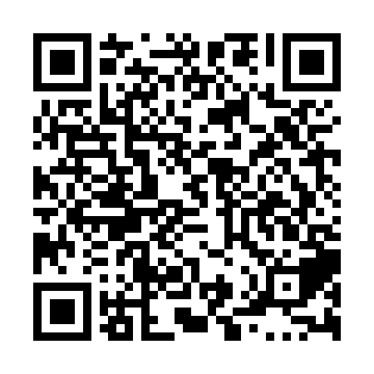
Ramadan times for Glen Emma, Quebec, Canada
Mon 11 Mar 2024 - Wed 10 Apr 2024
High Latitude Method: Angle Based Rule
Prayer Calculation Method: Islamic Society of North America
Asar Calculation Method: Hanafi

Date | Day | Fajr | Suhur | Sunrise | Dhuhr | Asr | Iftar | Maghrib | Isha
11 | Mon | 5:24 | 5:24 | 6:49 | 12:38 | 4:37 | 6:29 | 6:29 | 7:54
12 | Tue | 5:21 | 5:21 | 6:47 | 12:38 | 4:38 | 6:30 | 6:30 | 7:56
13 | Wed | 5:19 | 5:19 | 6:45 | 12:38 | 4:39 | 6:32 | 6:32 | 7:57
14 | Thu | 5:17 | 5:17 | 6:43 | 12:38 | 4:41 | 6:33 | 6:33 | 7:59
15 | Fri | 5:15 | 5:15 | 6:41 | 12:37 | 4:42 | 6:35 | 6:35 | 8:01
16 | Sat | 5:13 | 5:13 | 6:39 | 12:37 | 4:43 | 6:36 | 6:36 | 8:02
17 | Sun | 5:11 | 5:11 | 6:37 | 12:37 | 4:44 | 6:38 | 6:38 | 8:04
18 | Mon | 5:09 | 5:09 | 6:34 | 12:36 | 4:45 | 6:39 | 6:39 | 8:05
19 | Tue | 5:06 | 5:06 | 6:32 | 12:36 | 4:47 | 6:41 | 6:41 | 8:07
20 | Wed | 5:04 | 5:04 | 6:30 | 12:36 | 4:48 | 6:42 | 6:42 | 8:09
21 | Thu | 5:02 | 5:02 | 6:28 | 12:36 | 4:49 | 6:44 | 6:44 | 8:10
22 | Fri | 5:00 | 5:00 | 6:26 | 12:35 | 4:50 | 6:45 | 6:45 | 8:12
23 | Sat | 4:57 | 4:57 | 6:24 | 12:35 | 4:51 | 6:47 | 6:47 | 8:13
24 | Sun | 4:55 | 4:55 | 6:22 | 12:35 | 4:52 | 6:48 | 6:48 | 8:15
25 | Mon | 4:53 | 4:53 | 6:20 | 12:34 | 4:53 | 6:49 | 6:49 | 8:17
26 | Tue | 4:51 | 4:51 | 6:18 | 12:34 | 4:54 | 6:51 | 6:51 | 8:18
27 | Wed | 4:48 | 4:48 | 6:16 | 12:34 | 4:56 | 6:52 | 6:52 | 8:20
28 | Thu | 4:46 | 4:46 | 6:14 | 12:33 | 4:57 | 6:54 | 6:54 | 8:22
29 | Fri | 4:44 | 4:44 | 6:12 | 12:33 | 4:58 | 6:55 | 6:55 | 8:24
30 | Sat | 4:42 | 4:42 | 6:10 | 12:33 | 4:59 | 6:57 | 6:57 | 8:25
31 | Sun | 4:39 | 4:39 | 6:08 | 12:33 | 5:00 | 6:58 | 6:58 | 8:27
1 | Mon | 4:37 | 4:37 | 6:06 | 12:32 | 5:01 | 7:00 | 7:00 | 8:29
2 | Tue | 4:35 | 4:35 | 6:04 | 12:32 | 5:02 | 7:01 | 7:01 | 8:30
3 | Wed | 4:32 | 4:32 | 6:02 | 12:32 | 5:03 | 7:03 | 7:03 | 8:32
4 | Thu | 4:30 | 4:30 | 6:00 | 12:31 | 5:04 | 7:04 | 7:04 | 8:34
5 | Fri | 4:28 | 4:28 | 5:58 | 12:31 | 5:05 | 7:05 | 7:05 | 8:36
6 | Sat | 4:25 | 4:25 | 5:56 | 12:31 | 5:06 | 7:07 | 7:07 | 8:38
7 | Sun | 4:23 | 4:23 | 5:54 | 12:31 | 5:07 | 7:08 | 7:08 | 8:39
8 | Mon | 4:20 | 4:20 | 5:52 | 12:30 | 5:08 | 7:10 | 7:10 | 8:41
9 | Tue | 4:18 | 4:18 | 5:50 | 12:30 | 5:09 | 7:11 | 7:11 | 8:43
10 | Wed | 4:16 | 4:16 | 5:48 | 12:30 | 5:10 | 7:13 | 7:13 | 8:45
Prayer times provided by https://www.salahtimes.com

