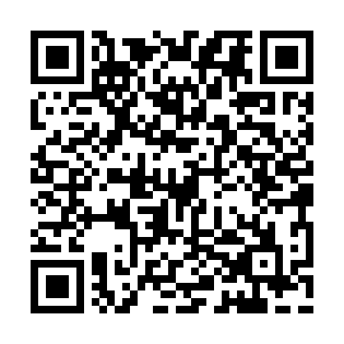
Ramadan times for Cove Inlet, South Carolina, USA
Mon 11 Mar 2024 - Wed 10 Apr 2024
High Latitude Method: Angle Based Rule
Prayer Calculation Method: Islamic Society of North America
Asar Calculation Method: Shafi

Date | Day | Fajr | Suhur | Sunrise | Dhuhr | Asr | Iftar | Maghrib | Isha
11 | Mon | 6:38 | 6:38 | 7:47 | 1:42 | 5:03 | 7:37 | 7:37 | 8:46
12 | Tue | 6:37 | 6:37 | 7:46 | 1:41 | 5:04 | 7:37 | 7:37 | 8:47
13 | Wed | 6:35 | 6:35 | 7:44 | 1:41 | 5:04 | 7:38 | 7:38 | 8:47
14 | Thu | 6:34 | 6:34 | 7:43 | 1:41 | 5:05 | 7:39 | 7:39 | 8:48
15 | Fri | 6:33 | 6:33 | 7:42 | 1:40 | 5:05 | 7:40 | 7:40 | 8:49
16 | Sat | 6:31 | 6:31 | 7:40 | 1:40 | 5:05 | 7:41 | 7:41 | 8:50
17 | Sun | 6:30 | 6:30 | 7:39 | 1:40 | 5:06 | 7:42 | 7:42 | 8:51
18 | Mon | 6:28 | 6:28 | 7:37 | 1:40 | 5:06 | 7:42 | 7:42 | 8:52
19 | Tue | 6:27 | 6:27 | 7:36 | 1:39 | 5:06 | 7:43 | 7:43 | 8:52
20 | Wed | 6:25 | 6:25 | 7:35 | 1:39 | 5:06 | 7:44 | 7:44 | 8:53
21 | Thu | 6:24 | 6:24 | 7:33 | 1:39 | 5:07 | 7:45 | 7:45 | 8:54
22 | Fri | 6:22 | 6:22 | 7:32 | 1:38 | 5:07 | 7:46 | 7:46 | 8:55
23 | Sat | 6:21 | 6:21 | 7:30 | 1:38 | 5:07 | 7:46 | 7:46 | 8:56
24 | Sun | 6:19 | 6:19 | 7:29 | 1:38 | 5:08 | 7:47 | 7:47 | 8:57
25 | Mon | 6:18 | 6:18 | 7:28 | 1:38 | 5:08 | 7:48 | 7:48 | 8:58
26 | Tue | 6:17 | 6:17 | 7:26 | 1:37 | 5:08 | 7:49 | 7:49 | 8:59
27 | Wed | 6:15 | 6:15 | 7:25 | 1:37 | 5:08 | 7:49 | 7:49 | 8:59
28 | Thu | 6:14 | 6:14 | 7:24 | 1:37 | 5:08 | 7:50 | 7:50 | 9:00
29 | Fri | 6:12 | 6:12 | 7:22 | 1:36 | 5:09 | 7:51 | 7:51 | 9:01
30 | Sat | 6:11 | 6:11 | 7:21 | 1:36 | 5:09 | 7:52 | 7:52 | 9:02
31 | Sun | 6:09 | 6:09 | 7:19 | 1:36 | 5:09 | 7:53 | 7:53 | 9:03
1 | Mon | 6:08 | 6:08 | 7:18 | 1:35 | 5:09 | 7:53 | 7:53 | 9:04
2 | Tue | 6:06 | 6:06 | 7:17 | 1:35 | 5:09 | 7:54 | 7:54 | 9:05
3 | Wed | 6:05 | 6:05 | 7:15 | 1:35 | 5:10 | 7:55 | 7:55 | 9:06
4 | Thu | 6:03 | 6:03 | 7:14 | 1:35 | 5:10 | 7:56 | 7:56 | 9:07
5 | Fri | 6:02 | 6:02 | 7:13 | 1:34 | 5:10 | 7:57 | 7:57 | 9:08
6 | Sat | 6:00 | 6:00 | 7:11 | 1:34 | 5:10 | 7:57 | 7:57 | 9:09
7 | Sun | 5:59 | 5:59 | 7:10 | 1:34 | 5:10 | 7:58 | 7:58 | 9:09
8 | Mon | 5:57 | 5:57 | 7:09 | 1:33 | 5:10 | 7:59 | 7:59 | 9:10
9 | Tue | 5:56 | 5:56 | 7:07 | 1:33 | 5:10 | 8:00 | 8:00 | 9:11
10 | Wed | 5:54 | 5:54 | 7:06 | 1:33 | 5:11 | 8:00 | 8:00 | 9:12
Prayer times provided by https://www.salahtimes.com

