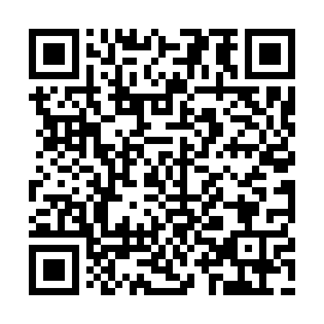
Ramadan times for Ilirska Bistrica, Slovenia
Mon 11 Mar 2024 - Wed 10 Apr 2024
High Latitude Method: Angle Based Rule
Prayer Calculation Method: Muslim World League
Asar Calculation Method: Hanafi

Date | Day | Fajr | Suhur | Sunrise | Dhuhr | Asr | Iftar | Maghrib | Isha
11 | Mon | 4:44 | 4:44 | 6:23 | 12:13 | 4:15 | 6:04 | 6:04 | 7:37
12 | Tue | 4:42 | 4:42 | 6:21 | 12:13 | 4:16 | 6:05 | 6:05 | 7:38
13 | Wed | 4:40 | 4:40 | 6:19 | 12:12 | 4:17 | 6:07 | 6:07 | 7:40
14 | Thu | 4:38 | 4:38 | 6:17 | 12:12 | 4:18 | 6:08 | 6:08 | 7:41
15 | Fri | 4:36 | 4:36 | 6:15 | 12:12 | 4:19 | 6:09 | 6:09 | 7:43
16 | Sat | 4:34 | 4:34 | 6:13 | 12:12 | 4:20 | 6:11 | 6:11 | 7:44
17 | Sun | 4:32 | 4:32 | 6:11 | 12:11 | 4:21 | 6:12 | 6:12 | 7:46
18 | Mon | 4:30 | 4:30 | 6:09 | 12:11 | 4:22 | 6:13 | 6:13 | 7:47
19 | Tue | 4:28 | 4:28 | 6:07 | 12:11 | 4:23 | 6:15 | 6:15 | 7:49
20 | Wed | 4:26 | 4:26 | 6:06 | 12:10 | 4:24 | 6:16 | 6:16 | 7:50
21 | Thu | 4:24 | 4:24 | 6:04 | 12:10 | 4:25 | 6:17 | 6:17 | 7:52
22 | Fri | 4:21 | 4:21 | 6:02 | 12:10 | 4:26 | 6:19 | 6:19 | 7:53
23 | Sat | 4:19 | 4:19 | 6:00 | 12:09 | 4:27 | 6:20 | 6:20 | 7:55
24 | Sun | 4:17 | 4:17 | 5:58 | 12:09 | 4:28 | 6:21 | 6:21 | 7:56
25 | Mon | 4:15 | 4:15 | 5:56 | 12:09 | 4:29 | 6:23 | 6:23 | 7:58
26 | Tue | 4:13 | 4:13 | 5:54 | 12:09 | 4:30 | 6:24 | 6:24 | 7:59
27 | Wed | 4:11 | 4:11 | 5:52 | 12:08 | 4:31 | 6:25 | 6:25 | 8:01
28 | Thu | 4:08 | 4:08 | 5:50 | 12:08 | 4:32 | 6:26 | 6:26 | 8:02
29 | Fri | 4:06 | 4:06 | 5:48 | 12:08 | 4:33 | 6:28 | 6:28 | 8:04
30 | Sat | 4:04 | 4:04 | 5:46 | 12:07 | 4:34 | 6:29 | 6:29 | 8:05
31 | Sun | 5:02 | 5:02 | 6:45 | 1:07 | 5:35 | 7:30 | 7:30 | 9:07
1 | Mon | 5:00 | 5:00 | 6:43 | 1:07 | 5:36 | 7:32 | 7:32 | 9:09
2 | Tue | 4:57 | 4:57 | 6:41 | 1:06 | 5:37 | 7:33 | 7:33 | 9:10
3 | Wed | 4:55 | 4:55 | 6:39 | 1:06 | 5:38 | 7:34 | 7:34 | 9:12
4 | Thu | 4:53 | 4:53 | 6:37 | 1:06 | 5:39 | 7:36 | 7:36 | 9:13
5 | Fri | 4:51 | 4:51 | 6:35 | 1:06 | 5:39 | 7:37 | 7:37 | 9:15
6 | Sat | 4:48 | 4:48 | 6:33 | 1:05 | 5:40 | 7:38 | 7:38 | 9:17
7 | Sun | 4:46 | 4:46 | 6:31 | 1:05 | 5:41 | 7:39 | 7:39 | 9:18
8 | Mon | 4:44 | 4:44 | 6:30 | 1:05 | 5:42 | 7:41 | 7:41 | 9:20
9 | Tue | 4:42 | 4:42 | 6:28 | 1:04 | 5:43 | 7:42 | 7:42 | 9:22
10 | Wed | 4:39 | 4:39 | 6:26 | 1:04 | 5:44 | 7:43 | 7:43 | 9:23
Prayer times provided by https://www.salahtimes.com

