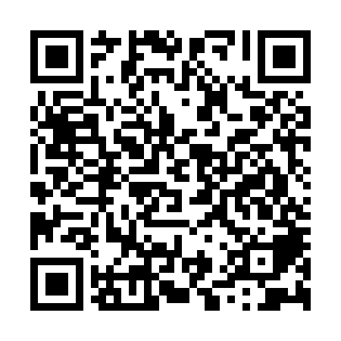
Ramadan times for Country Cove, North Carolina, USA
Mon 11 Mar 2024 - Wed 10 Apr 2024
High Latitude Method: Angle Based Rule
Prayer Calculation Method: Islamic Society of North America
Asar Calculation Method: Shafi

Date | Day | Fajr | Suhur | Sunrise | Dhuhr | Asr | Iftar | Maghrib | Isha
11 | Mon | 6:28 | 6:28 | 7:38 | 1:32 | 4:53 | 7:26 | 7:26 | 8:37
12 | Tue | 6:26 | 6:26 | 7:36 | 1:31 | 4:53 | 7:27 | 7:27 | 8:38
13 | Wed | 6:25 | 6:25 | 7:35 | 1:31 | 4:54 | 7:28 | 7:28 | 8:38
14 | Thu | 6:23 | 6:23 | 7:33 | 1:31 | 4:54 | 7:29 | 7:29 | 8:39
15 | Fri | 6:22 | 6:22 | 7:32 | 1:31 | 4:55 | 7:30 | 7:30 | 8:40
16 | Sat | 6:20 | 6:20 | 7:31 | 1:30 | 4:55 | 7:31 | 7:31 | 8:41
17 | Sun | 6:19 | 6:19 | 7:29 | 1:30 | 4:55 | 7:32 | 7:32 | 8:42
18 | Mon | 6:17 | 6:17 | 7:28 | 1:30 | 4:56 | 7:33 | 7:33 | 8:43
19 | Tue | 6:16 | 6:16 | 7:26 | 1:30 | 4:56 | 7:33 | 7:33 | 8:44
20 | Wed | 6:14 | 6:14 | 7:25 | 1:29 | 4:56 | 7:34 | 7:34 | 8:45
21 | Thu | 6:13 | 6:13 | 7:23 | 1:29 | 4:57 | 7:35 | 7:35 | 8:46
22 | Fri | 6:11 | 6:11 | 7:22 | 1:29 | 4:57 | 7:36 | 7:36 | 8:47
23 | Sat | 6:10 | 6:10 | 7:20 | 1:28 | 4:57 | 7:37 | 7:37 | 8:48
24 | Sun | 6:08 | 6:08 | 7:19 | 1:28 | 4:58 | 7:38 | 7:38 | 8:48
25 | Mon | 6:07 | 6:07 | 7:18 | 1:28 | 4:58 | 7:38 | 7:38 | 8:49
26 | Tue | 6:05 | 6:05 | 7:16 | 1:27 | 4:58 | 7:39 | 7:39 | 8:50
27 | Wed | 6:04 | 6:04 | 7:15 | 1:27 | 4:59 | 7:40 | 7:40 | 8:51
28 | Thu | 6:02 | 6:02 | 7:13 | 1:27 | 4:59 | 7:41 | 7:41 | 8:52
29 | Fri | 6:00 | 6:00 | 7:12 | 1:26 | 4:59 | 7:42 | 7:42 | 8:53
30 | Sat | 5:59 | 5:59 | 7:10 | 1:26 | 4:59 | 7:43 | 7:43 | 8:54
31 | Sun | 5:57 | 5:57 | 7:09 | 1:26 | 5:00 | 7:43 | 7:43 | 8:55
1 | Mon | 5:56 | 5:56 | 7:07 | 1:26 | 5:00 | 7:44 | 7:44 | 8:56
2 | Tue | 5:54 | 5:54 | 7:06 | 1:25 | 5:00 | 7:45 | 7:45 | 8:57
3 | Wed | 5:53 | 5:53 | 7:05 | 1:25 | 5:00 | 7:46 | 7:46 | 8:58
4 | Thu | 5:51 | 5:51 | 7:03 | 1:25 | 5:00 | 7:47 | 7:47 | 8:59
5 | Fri | 5:50 | 5:50 | 7:02 | 1:24 | 5:01 | 7:48 | 7:48 | 9:00
6 | Sat | 5:48 | 5:48 | 7:00 | 1:24 | 5:01 | 7:48 | 7:48 | 9:01
7 | Sun | 5:46 | 5:46 | 6:59 | 1:24 | 5:01 | 7:49 | 7:49 | 9:02
8 | Mon | 5:45 | 5:45 | 6:58 | 1:24 | 5:01 | 7:50 | 7:50 | 9:03
9 | Tue | 5:43 | 5:43 | 6:56 | 1:23 | 5:01 | 7:51 | 7:51 | 9:04
10 | Wed | 5:42 | 5:42 | 6:55 | 1:23 | 5:02 | 7:52 | 7:52 | 9:05
Prayer times provided by https://www.salahtimes.com

