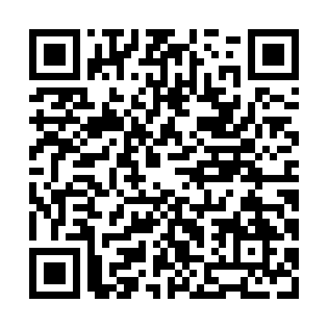
Ramadan times for Char Haim, Bangladesh
Mon 11 Mar 2024 - Wed 10 Apr 2024
High Latitude Method: None
Prayer Calculation Method: University of Islamic Sciences
Asar Calculation Method: Shafi

Date | Day | Fajr | Suhur | Sunrise | Dhuhr | Asr | Iftar | Maghrib | Isha
11 | Mon | 4:55 | 4:55 | 6:10 | 12:07 | 3:31 | 6:05 | 6:05 | 7:20
12 | Tue | 4:54 | 4:54 | 6:09 | 12:07 | 3:31 | 6:06 | 6:06 | 7:20
13 | Wed | 4:53 | 4:53 | 6:08 | 12:07 | 3:31 | 6:06 | 6:06 | 7:21
14 | Thu | 4:52 | 4:52 | 6:07 | 12:07 | 3:31 | 6:06 | 6:06 | 7:21
15 | Fri | 4:52 | 4:52 | 6:06 | 12:06 | 3:31 | 6:07 | 6:07 | 7:21
16 | Sat | 4:51 | 4:51 | 6:05 | 12:06 | 3:31 | 6:07 | 6:07 | 7:22
17 | Sun | 4:50 | 4:50 | 6:04 | 12:06 | 3:31 | 6:08 | 6:08 | 7:22
18 | Mon | 4:49 | 4:49 | 6:03 | 12:05 | 3:31 | 6:08 | 6:08 | 7:23
19 | Tue | 4:48 | 4:48 | 6:02 | 12:05 | 3:31 | 6:08 | 6:08 | 7:23
20 | Wed | 4:47 | 4:47 | 6:01 | 12:05 | 3:30 | 6:09 | 6:09 | 7:24
21 | Thu | 4:46 | 4:46 | 6:00 | 12:05 | 3:30 | 6:09 | 6:09 | 7:24
22 | Fri | 4:45 | 4:45 | 5:59 | 12:04 | 3:30 | 6:09 | 6:09 | 7:24
23 | Sat | 4:44 | 4:44 | 5:58 | 12:04 | 3:30 | 6:10 | 6:10 | 7:25
24 | Sun | 4:42 | 4:42 | 5:58 | 12:04 | 3:30 | 6:10 | 6:10 | 7:25
25 | Mon | 4:41 | 4:41 | 5:57 | 12:03 | 3:30 | 6:11 | 6:11 | 7:26
26 | Tue | 4:40 | 4:40 | 5:56 | 12:03 | 3:29 | 6:11 | 6:11 | 7:26
27 | Wed | 4:39 | 4:39 | 5:55 | 12:03 | 3:29 | 6:11 | 6:11 | 7:27
28 | Thu | 4:38 | 4:38 | 5:54 | 12:02 | 3:29 | 6:12 | 6:12 | 7:27
29 | Fri | 4:37 | 4:37 | 5:53 | 12:02 | 3:29 | 6:12 | 6:12 | 7:27
30 | Sat | 4:36 | 4:36 | 5:52 | 12:02 | 3:29 | 6:12 | 6:12 | 7:28
31 | Sun | 4:35 | 4:35 | 5:51 | 12:02 | 3:28 | 6:13 | 6:13 | 7:28
1 | Mon | 4:34 | 4:34 | 5:50 | 12:01 | 3:28 | 6:13 | 6:13 | 7:29
2 | Tue | 4:33 | 4:33 | 5:49 | 12:01 | 3:28 | 6:13 | 6:13 | 7:29
3 | Wed | 4:32 | 4:32 | 5:48 | 12:01 | 3:28 | 6:14 | 6:14 | 7:30
4 | Thu | 4:31 | 4:31 | 5:47 | 12:00 | 3:27 | 6:14 | 6:14 | 7:30
5 | Fri | 4:30 | 4:30 | 5:46 | 12:00 | 3:27 | 6:15 | 6:15 | 7:31
6 | Sat | 4:29 | 4:29 | 5:45 | 12:00 | 3:27 | 6:15 | 6:15 | 7:31
7 | Sun | 4:28 | 4:28 | 5:44 | 12:00 | 3:26 | 6:15 | 6:15 | 7:32
8 | Mon | 4:27 | 4:27 | 5:43 | 11:59 | 3:26 | 6:16 | 6:16 | 7:32
9 | Tue | 4:26 | 4:26 | 5:42 | 11:59 | 3:26 | 6:16 | 6:16 | 7:33
10 | Wed | 4:25 | 4:25 | 5:41 | 11:59 | 3:26 | 6:16 | 6:16 | 7:33
Prayer times provided by https://www.salahtimes.com

