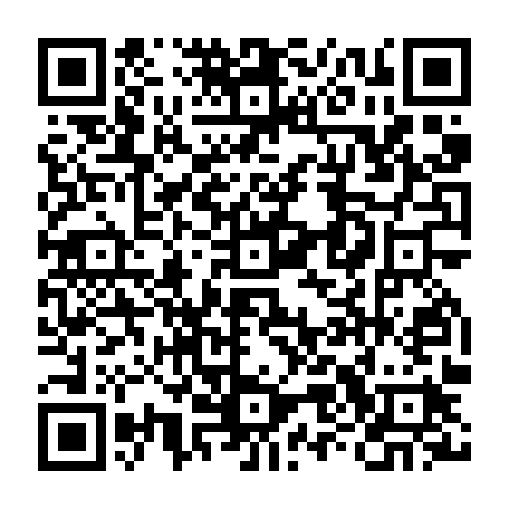
Ramadan times for Harbour Main-Chapel's Cove-Lakeview, Newfoundland and Labrador, Canada
Mon 11 Mar 2024 - Wed 10 Apr 2024
High Latitude Method: Angle Based Rule
Prayer Calculation Method: Islamic Society of North America
Asar Calculation Method: Hanafi

Date | Day | Fajr | Suhur | Sunrise | Dhuhr | Asr | Iftar | Maghrib | Isha
11 | Mon | 5:59 | 5:59 | 7:23 | 1:13 | 5:12 | 7:03 | 7:03 | 8:27
12 | Tue | 5:57 | 5:57 | 7:21 | 1:12 | 5:13 | 7:05 | 7:05 | 8:29
13 | Wed | 5:54 | 5:54 | 7:19 | 1:12 | 5:14 | 7:06 | 7:06 | 8:30
14 | Thu | 5:52 | 5:52 | 7:17 | 1:12 | 5:16 | 7:08 | 7:08 | 8:32
15 | Fri | 5:50 | 5:50 | 7:15 | 1:11 | 5:17 | 7:09 | 7:09 | 8:34
16 | Sat | 5:48 | 5:48 | 7:13 | 1:11 | 5:18 | 7:10 | 7:10 | 8:35
17 | Sun | 5:46 | 5:46 | 7:11 | 1:11 | 5:19 | 7:12 | 7:12 | 8:37
18 | Mon | 5:44 | 5:44 | 7:09 | 1:11 | 5:20 | 7:13 | 7:13 | 8:38
19 | Tue | 5:42 | 5:42 | 7:07 | 1:10 | 5:21 | 7:15 | 7:15 | 8:40
20 | Wed | 5:40 | 5:40 | 7:05 | 1:10 | 5:22 | 7:16 | 7:16 | 8:41
21 | Thu | 5:38 | 5:38 | 7:03 | 1:10 | 5:24 | 7:18 | 7:18 | 8:43
22 | Fri | 5:35 | 5:35 | 7:01 | 1:09 | 5:25 | 7:19 | 7:19 | 8:44
23 | Sat | 5:33 | 5:33 | 6:59 | 1:09 | 5:26 | 7:20 | 7:20 | 8:46
24 | Sun | 5:31 | 5:31 | 6:57 | 1:09 | 5:27 | 7:22 | 7:22 | 8:48
25 | Mon | 5:29 | 5:29 | 6:55 | 1:08 | 5:28 | 7:23 | 7:23 | 8:49
26 | Tue | 5:27 | 5:27 | 6:53 | 1:08 | 5:29 | 7:25 | 7:25 | 8:51
27 | Wed | 5:24 | 5:24 | 6:51 | 1:08 | 5:30 | 7:26 | 7:26 | 8:52
28 | Thu | 5:22 | 5:22 | 6:49 | 1:08 | 5:31 | 7:27 | 7:27 | 8:54
29 | Fri | 5:20 | 5:20 | 6:47 | 1:07 | 5:32 | 7:29 | 7:29 | 8:56
30 | Sat | 5:18 | 5:18 | 6:45 | 1:07 | 5:33 | 7:30 | 7:30 | 8:57
31 | Sun | 5:15 | 5:15 | 6:43 | 1:07 | 5:34 | 7:32 | 7:32 | 8:59
1 | Mon | 5:13 | 5:13 | 6:41 | 1:06 | 5:35 | 7:33 | 7:33 | 9:01
2 | Tue | 5:11 | 5:11 | 6:39 | 1:06 | 5:36 | 7:35 | 7:35 | 9:02
3 | Wed | 5:09 | 5:09 | 6:37 | 1:06 | 5:37 | 7:36 | 7:36 | 9:04
4 | Thu | 5:06 | 5:06 | 6:35 | 1:06 | 5:38 | 7:37 | 7:37 | 9:06
5 | Fri | 5:04 | 5:04 | 6:33 | 1:05 | 5:39 | 7:39 | 7:39 | 9:08
6 | Sat | 5:02 | 5:02 | 6:31 | 1:05 | 5:40 | 7:40 | 7:40 | 9:09
7 | Sun | 4:59 | 4:59 | 6:29 | 1:05 | 5:41 | 7:42 | 7:42 | 9:11
8 | Mon | 4:57 | 4:57 | 6:27 | 1:04 | 5:42 | 7:43 | 7:43 | 9:13
9 | Tue | 4:55 | 4:55 | 6:25 | 1:04 | 5:43 | 7:44 | 7:44 | 9:15
10 | Wed | 4:52 | 4:52 | 6:23 | 1:04 | 5:44 | 7:46 | 7:46 | 9:16
Prayer times provided by https://www.salahtimes.com

