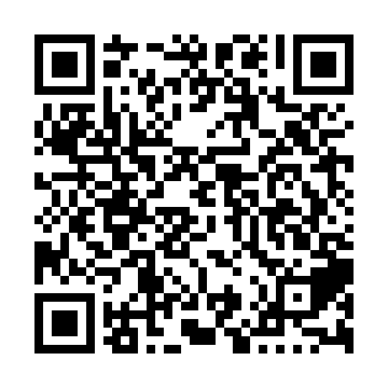
Ramadan times for Hamer Bay, Ontario, Canada
Mon 11 Mar 2024 - Wed 10 Apr 2024
High Latitude Method: Angle Based Rule
Prayer Calculation Method: Islamic Society of North America
Asar Calculation Method: Hanafi

Date | Day | Fajr | Suhur | Sunrise | Dhuhr | Asr | Iftar | Maghrib | Isha
11 | Mon | 6:17 | 6:17 | 7:38 | 1:29 | 5:31 | 7:21 | 7:21 | 8:41
12 | Tue | 6:15 | 6:15 | 7:36 | 1:29 | 5:32 | 7:22 | 7:22 | 8:43
13 | Wed | 6:13 | 6:13 | 7:34 | 1:28 | 5:33 | 7:23 | 7:23 | 8:44
14 | Thu | 6:12 | 6:12 | 7:32 | 1:28 | 5:35 | 7:25 | 7:25 | 8:46
15 | Fri | 6:10 | 6:10 | 7:31 | 1:28 | 5:36 | 7:26 | 7:26 | 8:47
16 | Sat | 6:08 | 6:08 | 7:29 | 1:28 | 5:37 | 7:27 | 7:27 | 8:48
17 | Sun | 6:06 | 6:06 | 7:27 | 1:27 | 5:38 | 7:28 | 7:28 | 8:50
18 | Mon | 6:04 | 6:04 | 7:25 | 1:27 | 5:39 | 7:30 | 7:30 | 8:51
19 | Tue | 6:02 | 6:02 | 7:23 | 1:27 | 5:40 | 7:31 | 7:31 | 8:53
20 | Wed | 6:00 | 6:00 | 7:21 | 1:26 | 5:41 | 7:32 | 7:32 | 8:54
21 | Thu | 5:58 | 5:58 | 7:19 | 1:26 | 5:42 | 7:34 | 7:34 | 8:55
22 | Fri | 5:56 | 5:56 | 7:17 | 1:26 | 5:43 | 7:35 | 7:35 | 8:57
23 | Sat | 5:54 | 5:54 | 7:15 | 1:25 | 5:44 | 7:36 | 7:36 | 8:58
24 | Sun | 5:52 | 5:52 | 7:14 | 1:25 | 5:45 | 7:38 | 7:38 | 9:00
25 | Mon | 5:50 | 5:50 | 7:12 | 1:25 | 5:46 | 7:39 | 7:39 | 9:01
26 | Tue | 5:47 | 5:47 | 7:10 | 1:25 | 5:47 | 7:40 | 7:40 | 9:03
27 | Wed | 5:45 | 5:45 | 7:08 | 1:24 | 5:48 | 7:41 | 7:41 | 9:04
28 | Thu | 5:43 | 5:43 | 7:06 | 1:24 | 5:48 | 7:43 | 7:43 | 9:06
29 | Fri | 5:41 | 5:41 | 7:04 | 1:24 | 5:49 | 7:44 | 7:44 | 9:07
30 | Sat | 5:39 | 5:39 | 7:02 | 1:23 | 5:50 | 7:45 | 7:45 | 9:09
31 | Sun | 5:37 | 5:37 | 7:00 | 1:23 | 5:51 | 7:47 | 7:47 | 9:10
1 | Mon | 5:35 | 5:35 | 6:59 | 1:23 | 5:52 | 7:48 | 7:48 | 9:12
2 | Tue | 5:33 | 5:33 | 6:57 | 1:22 | 5:53 | 7:49 | 7:49 | 9:13
3 | Wed | 5:31 | 5:31 | 6:55 | 1:22 | 5:54 | 7:50 | 7:50 | 9:15
4 | Thu | 5:29 | 5:29 | 6:53 | 1:22 | 5:55 | 7:52 | 7:52 | 9:16
5 | Fri | 5:26 | 5:26 | 6:51 | 1:22 | 5:56 | 7:53 | 7:53 | 9:18
6 | Sat | 5:24 | 5:24 | 6:49 | 1:21 | 5:57 | 7:54 | 7:54 | 9:19
7 | Sun | 5:22 | 5:22 | 6:47 | 1:21 | 5:57 | 7:55 | 7:55 | 9:21
8 | Mon | 5:20 | 5:20 | 6:46 | 1:21 | 5:58 | 7:57 | 7:57 | 9:22
9 | Tue | 5:18 | 5:18 | 6:44 | 1:21 | 5:59 | 7:58 | 7:58 | 9:24
10 | Wed | 5:16 | 5:16 | 6:42 | 1:20 | 6:00 | 7:59 | 7:59 | 9:26
Prayer times provided by https://www.salahtimes.com

