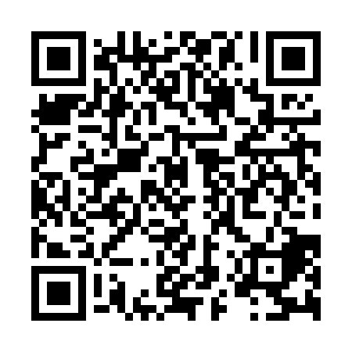
Ramadan times for Kletsk, Belarus
Mon 11 Mar 2024 - Wed 10 Apr 2024
High Latitude Method: Angle Based Rule
Prayer Calculation Method: Muslim World League
Asar Calculation Method: Shafi

Date | Day | Fajr | Suhur | Sunrise | Dhuhr | Asr | Iftar | Maghrib | Isha
11 | Mon | 5:41 | 5:41 | 7:37 | 1:23 | 4:27 | 7:11 | 7:11 | 9:00
12 | Tue | 5:38 | 5:38 | 7:34 | 1:23 | 4:28 | 7:13 | 7:13 | 9:02
13 | Wed | 5:36 | 5:36 | 7:32 | 1:23 | 4:29 | 7:15 | 7:15 | 9:04
14 | Thu | 5:33 | 5:33 | 7:30 | 1:23 | 4:30 | 7:17 | 7:17 | 9:06
15 | Fri | 5:31 | 5:31 | 7:27 | 1:22 | 4:32 | 7:18 | 7:18 | 9:08
16 | Sat | 5:28 | 5:28 | 7:25 | 1:22 | 4:33 | 7:20 | 7:20 | 9:10
17 | Sun | 5:25 | 5:25 | 7:22 | 1:22 | 4:34 | 7:22 | 7:22 | 9:12
18 | Mon | 5:23 | 5:23 | 7:20 | 1:21 | 4:35 | 7:24 | 7:24 | 9:14
19 | Tue | 5:20 | 5:20 | 7:18 | 1:21 | 4:36 | 7:26 | 7:26 | 9:16
20 | Wed | 5:17 | 5:17 | 7:15 | 1:21 | 4:37 | 7:27 | 7:27 | 9:18
21 | Thu | 5:14 | 5:14 | 7:13 | 1:21 | 4:38 | 7:29 | 7:29 | 9:21
22 | Fri | 5:12 | 5:12 | 7:10 | 1:20 | 4:39 | 7:31 | 7:31 | 9:23
23 | Sat | 5:09 | 5:09 | 7:08 | 1:20 | 4:40 | 7:33 | 7:33 | 9:25
24 | Sun | 5:06 | 5:06 | 7:06 | 1:20 | 4:42 | 7:35 | 7:35 | 9:27
25 | Mon | 5:03 | 5:03 | 7:03 | 1:19 | 4:43 | 7:36 | 7:36 | 9:29
26 | Tue | 5:00 | 5:00 | 7:01 | 1:19 | 4:44 | 7:38 | 7:38 | 9:32
27 | Wed | 4:57 | 4:57 | 6:58 | 1:19 | 4:45 | 7:40 | 7:40 | 9:34
28 | Thu | 4:54 | 4:54 | 6:56 | 1:18 | 4:46 | 7:42 | 7:42 | 9:36
29 | Fri | 4:51 | 4:51 | 6:54 | 1:18 | 4:47 | 7:44 | 7:44 | 9:38
30 | Sat | 4:49 | 4:49 | 6:51 | 1:18 | 4:48 | 7:45 | 7:45 | 9:41
31 | Sun | 4:46 | 4:46 | 6:49 | 1:18 | 4:49 | 7:47 | 7:47 | 9:43
1 | Mon | 4:43 | 4:43 | 6:46 | 1:17 | 4:50 | 7:49 | 7:49 | 9:45
2 | Tue | 4:39 | 4:39 | 6:44 | 1:17 | 4:51 | 7:51 | 7:51 | 9:48
3 | Wed | 4:36 | 4:36 | 6:42 | 1:17 | 4:52 | 7:53 | 7:53 | 9:50
4 | Thu | 4:33 | 4:33 | 6:39 | 1:16 | 4:53 | 7:54 | 7:54 | 9:53
5 | Fri | 4:30 | 4:30 | 6:37 | 1:16 | 4:53 | 7:56 | 7:56 | 9:55
6 | Sat | 4:27 | 4:27 | 6:35 | 1:16 | 4:54 | 7:58 | 7:58 | 9:57
7 | Sun | 4:24 | 4:24 | 6:32 | 1:15 | 4:55 | 8:00 | 8:00 | 10:00
8 | Mon | 4:21 | 4:21 | 6:30 | 1:15 | 4:56 | 8:01 | 8:01 | 10:03
9 | Tue | 4:18 | 4:18 | 6:28 | 1:15 | 4:57 | 8:03 | 8:03 | 10:05
10 | Wed | 4:14 | 4:14 | 6:25 | 1:15 | 4:58 | 8:05 | 8:05 | 10:08
Prayer times provided by https://www.salahtimes.com

