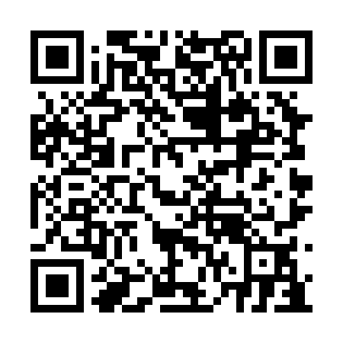
Ramadan times for Cherry Point, Alberta, Canada
Mon 11 Mar 2024 - Wed 10 Apr 2024
High Latitude Method: Angle Based Rule
Prayer Calculation Method: Islamic Society of North America
Asar Calculation Method: Hanafi

Date | Day | Fajr | Suhur | Sunrise | Dhuhr | Asr | Iftar | Maghrib | Isha
11 | Mon | 6:41 | 6:41 | 8:24 | 2:10 | 5:55 | 7:57 | 7:57 | 9:40
12 | Tue | 6:38 | 6:38 | 8:21 | 2:09 | 5:56 | 7:59 | 7:59 | 9:42
13 | Wed | 6:35 | 6:35 | 8:19 | 2:09 | 5:58 | 8:01 | 8:01 | 9:44
14 | Thu | 6:33 | 6:33 | 8:16 | 2:09 | 6:00 | 8:03 | 8:03 | 9:46
15 | Fri | 6:30 | 6:30 | 8:13 | 2:08 | 6:02 | 8:05 | 8:05 | 9:49
16 | Sat | 6:27 | 6:27 | 8:11 | 2:08 | 6:03 | 8:07 | 8:07 | 9:51
17 | Sun | 6:24 | 6:24 | 8:08 | 2:08 | 6:05 | 8:09 | 8:09 | 9:53
18 | Mon | 6:21 | 6:21 | 8:05 | 2:08 | 6:07 | 8:11 | 8:11 | 9:56
19 | Tue | 6:18 | 6:18 | 8:03 | 2:07 | 6:08 | 8:13 | 8:13 | 9:58
20 | Wed | 6:15 | 6:15 | 8:00 | 2:07 | 6:10 | 8:15 | 8:15 | 10:00
21 | Thu | 6:12 | 6:12 | 7:57 | 2:07 | 6:12 | 8:17 | 8:17 | 10:03
22 | Fri | 6:09 | 6:09 | 7:55 | 2:06 | 6:13 | 8:19 | 8:19 | 10:05
23 | Sat | 6:06 | 6:06 | 7:52 | 2:06 | 6:15 | 8:21 | 8:21 | 10:08
24 | Sun | 6:03 | 6:03 | 7:49 | 2:06 | 6:16 | 8:23 | 8:23 | 10:10
25 | Mon | 6:00 | 6:00 | 7:47 | 2:06 | 6:18 | 8:26 | 8:26 | 10:13
26 | Tue | 5:57 | 5:57 | 7:44 | 2:05 | 6:20 | 8:28 | 8:28 | 10:15
27 | Wed | 5:54 | 5:54 | 7:41 | 2:05 | 6:21 | 8:30 | 8:30 | 10:18
28 | Thu | 5:51 | 5:51 | 7:39 | 2:05 | 6:23 | 8:32 | 8:32 | 10:20
29 | Fri | 5:47 | 5:47 | 7:36 | 2:04 | 6:24 | 8:34 | 8:34 | 10:23
30 | Sat | 5:44 | 5:44 | 7:33 | 2:04 | 6:26 | 8:36 | 8:36 | 10:25
31 | Sun | 5:41 | 5:41 | 7:31 | 2:04 | 6:27 | 8:38 | 8:38 | 10:28
1 | Mon | 5:38 | 5:38 | 7:28 | 2:03 | 6:29 | 8:40 | 8:40 | 10:31
2 | Tue | 5:35 | 5:35 | 7:26 | 2:03 | 6:30 | 8:42 | 8:42 | 10:33
3 | Wed | 5:31 | 5:31 | 7:23 | 2:03 | 6:32 | 8:44 | 8:44 | 10:36
4 | Thu | 5:28 | 5:28 | 7:20 | 2:03 | 6:33 | 8:46 | 8:46 | 10:39
5 | Fri | 5:25 | 5:25 | 7:18 | 2:02 | 6:35 | 8:48 | 8:48 | 10:42
6 | Sat | 5:21 | 5:21 | 7:15 | 2:02 | 6:36 | 8:50 | 8:50 | 10:44
7 | Sun | 5:18 | 5:18 | 7:12 | 2:02 | 6:38 | 8:52 | 8:52 | 10:47
8 | Mon | 5:14 | 5:14 | 7:10 | 2:01 | 6:39 | 8:54 | 8:54 | 10:50
9 | Tue | 5:11 | 5:11 | 7:07 | 2:01 | 6:41 | 8:56 | 8:56 | 10:53
10 | Wed | 5:08 | 5:08 | 7:05 | 2:01 | 6:42 | 8:58 | 8:58 | 10:56
Prayer times provided by https://www.salahtimes.com

