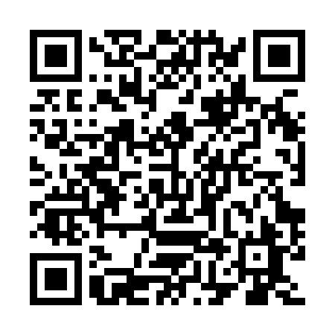
Ramadan times for Goffs, Nova Scotia, Canada
Mon 11 Mar 2024 - Wed 10 Apr 2024
High Latitude Method: Angle Based Rule
Prayer Calculation Method: Islamic Society of North America
Asar Calculation Method: Hanafi

Date | Day | Fajr | Suhur | Sunrise | Dhuhr | Asr | Iftar | Maghrib | Isha
11 | Mon | 6:13 | 6:13 | 7:33 | 1:24 | 5:27 | 7:15 | 7:15 | 8:36
12 | Tue | 6:11 | 6:11 | 7:31 | 1:23 | 5:28 | 7:17 | 7:17 | 8:37
13 | Wed | 6:09 | 6:09 | 7:29 | 1:23 | 5:29 | 7:18 | 7:18 | 8:39
14 | Thu | 6:07 | 6:07 | 7:27 | 1:23 | 5:30 | 7:19 | 7:19 | 8:40
15 | Fri | 6:05 | 6:05 | 7:25 | 1:23 | 5:31 | 7:21 | 7:21 | 8:41
16 | Sat | 6:03 | 6:03 | 7:24 | 1:22 | 5:32 | 7:22 | 7:22 | 8:43
17 | Sun | 6:01 | 6:01 | 7:22 | 1:22 | 5:33 | 7:23 | 7:23 | 8:44
18 | Mon | 5:59 | 5:59 | 7:20 | 1:22 | 5:34 | 7:25 | 7:25 | 8:45
19 | Tue | 5:57 | 5:57 | 7:18 | 1:22 | 5:35 | 7:26 | 7:26 | 8:47
20 | Wed | 5:55 | 5:55 | 7:16 | 1:21 | 5:36 | 7:27 | 7:27 | 8:48
21 | Thu | 5:53 | 5:53 | 7:14 | 1:21 | 5:37 | 7:28 | 7:28 | 8:50
22 | Fri | 5:51 | 5:51 | 7:12 | 1:21 | 5:38 | 7:30 | 7:30 | 8:51
23 | Sat | 5:49 | 5:49 | 7:10 | 1:20 | 5:39 | 7:31 | 7:31 | 8:52
24 | Sun | 5:47 | 5:47 | 7:09 | 1:20 | 5:40 | 7:32 | 7:32 | 8:54
25 | Mon | 5:45 | 5:45 | 7:07 | 1:20 | 5:41 | 7:33 | 7:33 | 8:55
26 | Tue | 5:43 | 5:43 | 7:05 | 1:19 | 5:42 | 7:35 | 7:35 | 8:57
27 | Wed | 5:41 | 5:41 | 7:03 | 1:19 | 5:42 | 7:36 | 7:36 | 8:58
28 | Thu | 5:39 | 5:39 | 7:01 | 1:19 | 5:43 | 7:37 | 7:37 | 9:00
29 | Fri | 5:37 | 5:37 | 6:59 | 1:19 | 5:44 | 7:39 | 7:39 | 9:01
30 | Sat | 5:35 | 5:35 | 6:57 | 1:18 | 5:45 | 7:40 | 7:40 | 9:03
31 | Sun | 5:33 | 5:33 | 6:56 | 1:18 | 5:46 | 7:41 | 7:41 | 9:04
1 | Mon | 5:31 | 5:31 | 6:54 | 1:18 | 5:47 | 7:42 | 7:42 | 9:06
2 | Tue | 5:29 | 5:29 | 6:52 | 1:17 | 5:48 | 7:44 | 7:44 | 9:07
3 | Wed | 5:27 | 5:27 | 6:50 | 1:17 | 5:49 | 7:45 | 7:45 | 9:09
4 | Thu | 5:24 | 5:24 | 6:48 | 1:17 | 5:50 | 7:46 | 7:46 | 9:10
5 | Fri | 5:22 | 5:22 | 6:46 | 1:16 | 5:51 | 7:47 | 7:47 | 9:12
6 | Sat | 5:20 | 5:20 | 6:45 | 1:16 | 5:51 | 7:49 | 7:49 | 9:13
7 | Sun | 5:18 | 5:18 | 6:43 | 1:16 | 5:52 | 7:50 | 7:50 | 9:15
8 | Mon | 5:16 | 5:16 | 6:41 | 1:16 | 5:53 | 7:51 | 7:51 | 9:16
9 | Tue | 5:14 | 5:14 | 6:39 | 1:15 | 5:54 | 7:52 | 7:52 | 9:18
10 | Wed | 5:12 | 5:12 | 6:37 | 1:15 | 5:55 | 7:54 | 7:54 | 9:19
Prayer times provided by https://www.salahtimes.com

