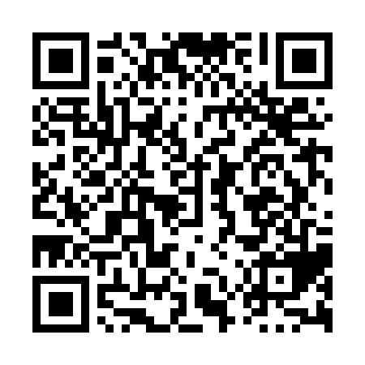
Ramadan times for Haggertys Cove, New Brunswick, Canada
Mon 11 Mar 2024 - Wed 10 Apr 2024
High Latitude Method: Angle Based Rule
Prayer Calculation Method: Islamic Society of North America
Asar Calculation Method: Hanafi

Date | Day | Fajr | Suhur | Sunrise | Dhuhr | Asr | Iftar | Maghrib | Isha
11 | Mon | 6:24 | 6:24 | 7:45 | 1:36 | 5:38 | 7:28 | 7:28 | 8:48
12 | Tue | 6:23 | 6:23 | 7:43 | 1:36 | 5:39 | 7:29 | 7:29 | 8:50
13 | Wed | 6:21 | 6:21 | 7:41 | 1:35 | 5:41 | 7:30 | 7:30 | 8:51
14 | Thu | 6:19 | 6:19 | 7:39 | 1:35 | 5:42 | 7:31 | 7:31 | 8:52
15 | Fri | 6:17 | 6:17 | 7:38 | 1:35 | 5:43 | 7:33 | 7:33 | 8:54
16 | Sat | 6:15 | 6:15 | 7:36 | 1:35 | 5:44 | 7:34 | 7:34 | 8:55
17 | Sun | 6:13 | 6:13 | 7:34 | 1:34 | 5:45 | 7:35 | 7:35 | 8:57
18 | Mon | 6:11 | 6:11 | 7:32 | 1:34 | 5:46 | 7:37 | 7:37 | 8:58
19 | Tue | 6:09 | 6:09 | 7:30 | 1:34 | 5:47 | 7:38 | 7:38 | 8:59
20 | Wed | 6:07 | 6:07 | 7:28 | 1:33 | 5:48 | 7:39 | 7:39 | 9:01
21 | Thu | 6:05 | 6:05 | 7:26 | 1:33 | 5:49 | 7:41 | 7:41 | 9:02
22 | Fri | 6:03 | 6:03 | 7:24 | 1:33 | 5:50 | 7:42 | 7:42 | 9:04
23 | Sat | 6:01 | 6:01 | 7:23 | 1:32 | 5:51 | 7:43 | 7:43 | 9:05
24 | Sun | 5:59 | 5:59 | 7:21 | 1:32 | 5:52 | 7:44 | 7:44 | 9:06
25 | Mon | 5:57 | 5:57 | 7:19 | 1:32 | 5:53 | 7:46 | 7:46 | 9:08
26 | Tue | 5:55 | 5:55 | 7:17 | 1:32 | 5:54 | 7:47 | 7:47 | 9:09
27 | Wed | 5:53 | 5:53 | 7:15 | 1:31 | 5:55 | 7:48 | 7:48 | 9:11
28 | Thu | 5:51 | 5:51 | 7:13 | 1:31 | 5:55 | 7:50 | 7:50 | 9:12
29 | Fri | 5:48 | 5:48 | 7:11 | 1:31 | 5:56 | 7:51 | 7:51 | 9:14
30 | Sat | 5:46 | 5:46 | 7:09 | 1:30 | 5:57 | 7:52 | 7:52 | 9:15
31 | Sun | 5:44 | 5:44 | 7:08 | 1:30 | 5:58 | 7:53 | 7:53 | 9:17
1 | Mon | 5:42 | 5:42 | 7:06 | 1:30 | 5:59 | 7:55 | 7:55 | 9:18
2 | Tue | 5:40 | 5:40 | 7:04 | 1:29 | 6:00 | 7:56 | 7:56 | 9:20
3 | Wed | 5:38 | 5:38 | 7:02 | 1:29 | 6:01 | 7:57 | 7:57 | 9:21
4 | Thu | 5:36 | 5:36 | 7:00 | 1:29 | 6:02 | 7:58 | 7:58 | 9:23
5 | Fri | 5:34 | 5:34 | 6:58 | 1:29 | 6:03 | 8:00 | 8:00 | 9:24
6 | Sat | 5:32 | 5:32 | 6:56 | 1:28 | 6:04 | 8:01 | 8:01 | 9:26
7 | Sun | 5:30 | 5:30 | 6:55 | 1:28 | 6:04 | 8:02 | 8:02 | 9:28
8 | Mon | 5:27 | 5:27 | 6:53 | 1:28 | 6:05 | 8:04 | 8:04 | 9:29
9 | Tue | 5:25 | 5:25 | 6:51 | 1:27 | 6:06 | 8:05 | 8:05 | 9:31
10 | Wed | 5:23 | 5:23 | 6:49 | 1:27 | 6:07 | 8:06 | 8:06 | 9:32
Prayer times provided by https://www.salahtimes.com

