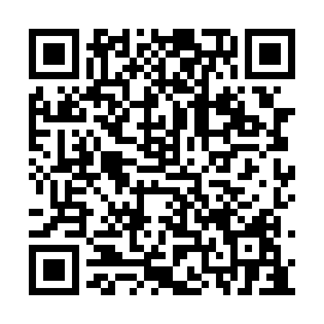
Ramadan times for Gussetts Cove, Newfoundland and Labrador, Canada
Mon 11 Mar 2024 - Wed 10 Apr 2024
High Latitude Method: Angle Based Rule
Prayer Calculation Method: Islamic Society of North America
Asar Calculation Method: Hanafi

Date | Day | Fajr | Suhur | Sunrise | Dhuhr | Asr | Iftar | Maghrib | Isha
11 | Mon | 5:58 | 5:58 | 7:23 | 1:12 | 5:11 | 7:03 | 7:03 | 8:28
12 | Tue | 5:56 | 5:56 | 7:21 | 1:12 | 5:12 | 7:04 | 7:04 | 8:29
13 | Wed | 5:54 | 5:54 | 7:19 | 1:12 | 5:13 | 7:06 | 7:06 | 8:31
14 | Thu | 5:51 | 5:51 | 7:16 | 1:11 | 5:15 | 7:07 | 7:07 | 8:32
15 | Fri | 5:49 | 5:49 | 7:14 | 1:11 | 5:16 | 7:09 | 7:09 | 8:34
16 | Sat | 5:47 | 5:47 | 7:12 | 1:11 | 5:17 | 7:10 | 7:10 | 8:35
17 | Sun | 5:45 | 5:45 | 7:10 | 1:11 | 5:18 | 7:12 | 7:12 | 8:37
18 | Mon | 5:43 | 5:43 | 7:08 | 1:10 | 5:19 | 7:13 | 7:13 | 8:39
19 | Tue | 5:41 | 5:41 | 7:06 | 1:10 | 5:21 | 7:14 | 7:14 | 8:40
20 | Wed | 5:39 | 5:39 | 7:04 | 1:10 | 5:22 | 7:16 | 7:16 | 8:42
21 | Thu | 5:36 | 5:36 | 7:02 | 1:09 | 5:23 | 7:17 | 7:17 | 8:43
22 | Fri | 5:34 | 5:34 | 7:00 | 1:09 | 5:24 | 7:19 | 7:19 | 8:45
23 | Sat | 5:32 | 5:32 | 6:58 | 1:09 | 5:25 | 7:20 | 7:20 | 8:47
24 | Sun | 5:30 | 5:30 | 6:56 | 1:08 | 5:26 | 7:22 | 7:22 | 8:48
25 | Mon | 5:27 | 5:27 | 6:54 | 1:08 | 5:27 | 7:23 | 7:23 | 8:50
26 | Tue | 5:25 | 5:25 | 6:52 | 1:08 | 5:28 | 7:25 | 7:25 | 8:52
27 | Wed | 5:23 | 5:23 | 6:50 | 1:08 | 5:29 | 7:26 | 7:26 | 8:53
28 | Thu | 5:21 | 5:21 | 6:48 | 1:07 | 5:30 | 7:27 | 7:27 | 8:55
29 | Fri | 5:18 | 5:18 | 6:46 | 1:07 | 5:32 | 7:29 | 7:29 | 8:57
30 | Sat | 5:16 | 5:16 | 6:44 | 1:07 | 5:33 | 7:30 | 7:30 | 8:58
31 | Sun | 5:14 | 5:14 | 6:42 | 1:06 | 5:34 | 7:32 | 7:32 | 9:00
1 | Mon | 5:11 | 5:11 | 6:40 | 1:06 | 5:35 | 7:33 | 7:33 | 9:02
2 | Tue | 5:09 | 5:09 | 6:38 | 1:06 | 5:36 | 7:35 | 7:35 | 9:03
3 | Wed | 5:07 | 5:07 | 6:36 | 1:05 | 5:37 | 7:36 | 7:36 | 9:05
4 | Thu | 5:05 | 5:05 | 6:34 | 1:05 | 5:38 | 7:37 | 7:37 | 9:07
5 | Fri | 5:02 | 5:02 | 6:32 | 1:05 | 5:39 | 7:39 | 7:39 | 9:09
6 | Sat | 5:00 | 5:00 | 6:30 | 1:05 | 5:40 | 7:40 | 7:40 | 9:10
7 | Sun | 4:58 | 4:58 | 6:28 | 1:04 | 5:41 | 7:42 | 7:42 | 9:12
8 | Mon | 4:55 | 4:55 | 6:26 | 1:04 | 5:42 | 7:43 | 7:43 | 9:14
9 | Tue | 4:53 | 4:53 | 6:24 | 1:04 | 5:43 | 7:45 | 7:45 | 9:16
10 | Wed | 4:51 | 4:51 | 6:22 | 1:04 | 5:44 | 7:46 | 7:46 | 9:18
Prayer times provided by https://www.salahtimes.com

