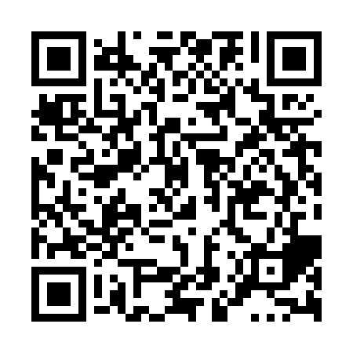
Ramadan times for Glenbow, Alberta, Canada
Mon 11 Mar 2024 - Wed 10 Apr 2024
High Latitude Method: Angle Based Rule
Prayer Calculation Method: Islamic Society of North America
Asar Calculation Method: Hanafi

Date | Day | Fajr | Suhur | Sunrise | Dhuhr | Asr | Iftar | Maghrib | Isha
11 | Mon | 6:28 | 6:28 | 7:59 | 1:47 | 5:42 | 7:37 | 7:37 | 9:08
12 | Tue | 6:26 | 6:26 | 7:57 | 1:47 | 5:43 | 7:38 | 7:38 | 9:10
13 | Wed | 6:23 | 6:23 | 7:54 | 1:47 | 5:44 | 7:40 | 7:40 | 9:11
14 | Thu | 6:21 | 6:21 | 7:52 | 1:47 | 5:46 | 7:42 | 7:42 | 9:13
15 | Fri | 6:19 | 6:19 | 7:50 | 1:46 | 5:47 | 7:43 | 7:43 | 9:15
16 | Sat | 6:16 | 6:16 | 7:48 | 1:46 | 5:48 | 7:45 | 7:45 | 9:17
17 | Sun | 6:14 | 6:14 | 7:45 | 1:46 | 5:50 | 7:47 | 7:47 | 9:19
18 | Mon | 6:11 | 6:11 | 7:43 | 1:45 | 5:51 | 7:49 | 7:49 | 9:21
19 | Tue | 6:09 | 6:09 | 7:41 | 1:45 | 5:52 | 7:50 | 7:50 | 9:22
20 | Wed | 6:06 | 6:06 | 7:39 | 1:45 | 5:54 | 7:52 | 7:52 | 9:24
21 | Thu | 6:04 | 6:04 | 7:36 | 1:44 | 5:55 | 7:54 | 7:54 | 9:26
22 | Fri | 6:02 | 6:02 | 7:34 | 1:44 | 5:56 | 7:55 | 7:55 | 9:28
23 | Sat | 5:59 | 5:59 | 7:32 | 1:44 | 5:58 | 7:57 | 7:57 | 9:30
24 | Sun | 5:57 | 5:57 | 7:30 | 1:44 | 5:59 | 7:59 | 7:59 | 9:32
25 | Mon | 5:54 | 5:54 | 7:27 | 1:43 | 6:00 | 8:00 | 8:00 | 9:34
26 | Tue | 5:52 | 5:52 | 7:25 | 1:43 | 6:02 | 8:02 | 8:02 | 9:36
27 | Wed | 5:49 | 5:49 | 7:23 | 1:43 | 6:03 | 8:03 | 8:03 | 9:38
28 | Thu | 5:46 | 5:46 | 7:21 | 1:42 | 6:04 | 8:05 | 8:05 | 9:40
29 | Fri | 5:44 | 5:44 | 7:18 | 1:42 | 6:05 | 8:07 | 8:07 | 9:42
30 | Sat | 5:41 | 5:41 | 7:16 | 1:42 | 6:07 | 8:08 | 8:08 | 9:44
31 | Sun | 5:39 | 5:39 | 7:14 | 1:41 | 6:08 | 8:10 | 8:10 | 9:46
1 | Mon | 5:36 | 5:36 | 7:12 | 1:41 | 6:09 | 8:12 | 8:12 | 9:48
2 | Tue | 5:33 | 5:33 | 7:09 | 1:41 | 6:10 | 8:13 | 8:13 | 9:50
3 | Wed | 5:31 | 5:31 | 7:07 | 1:41 | 6:11 | 8:15 | 8:15 | 9:52
4 | Thu | 5:28 | 5:28 | 7:05 | 1:40 | 6:13 | 8:17 | 8:17 | 9:54
5 | Fri | 5:26 | 5:26 | 7:03 | 1:40 | 6:14 | 8:18 | 8:18 | 9:56
6 | Sat | 5:23 | 5:23 | 7:00 | 1:40 | 6:15 | 8:20 | 8:20 | 9:58
7 | Sun | 5:20 | 5:20 | 6:58 | 1:39 | 6:16 | 8:22 | 8:22 | 10:00
8 | Mon | 5:17 | 5:17 | 6:56 | 1:39 | 6:17 | 8:23 | 8:23 | 10:02
9 | Tue | 5:15 | 5:15 | 6:54 | 1:39 | 6:18 | 8:25 | 8:25 | 10:04
10 | Wed | 5:12 | 5:12 | 6:52 | 1:39 | 6:19 | 8:27 | 8:27 | 10:07
Prayer times provided by https://www.salahtimes.com

