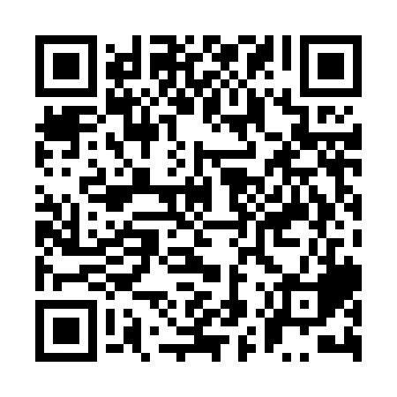
Ramadan times for Ichikawa, Japan
Mon 11 Mar 2024 - Wed 10 Apr 2024
High Latitude Method: None
Prayer Calculation Method: Muslim World League
Asar Calculation Method: Shafi

Date | Day | Fajr | Suhur | Sunrise | Dhuhr | Asr | Iftar | Maghrib | Isha
11 | Mon | 4:32 | 4:32 | 5:57 | 11:50 | 3:11 | 5:44 | 5:44 | 7:04
12 | Tue | 4:31 | 4:31 | 5:55 | 11:50 | 3:12 | 5:45 | 5:45 | 7:05
13 | Wed | 4:29 | 4:29 | 5:54 | 11:50 | 3:12 | 5:46 | 5:46 | 7:06
14 | Thu | 4:28 | 4:28 | 5:53 | 11:49 | 3:12 | 5:47 | 5:47 | 7:07
15 | Fri | 4:26 | 4:26 | 5:51 | 11:49 | 3:13 | 5:48 | 5:48 | 7:08
16 | Sat | 4:25 | 4:25 | 5:50 | 11:49 | 3:13 | 5:49 | 5:49 | 7:09
17 | Sun | 4:23 | 4:23 | 5:48 | 11:49 | 3:14 | 5:49 | 5:49 | 7:10
18 | Mon | 4:22 | 4:22 | 5:47 | 11:48 | 3:14 | 5:50 | 5:50 | 7:11
19 | Tue | 4:20 | 4:20 | 5:45 | 11:48 | 3:14 | 5:51 | 5:51 | 7:11
20 | Wed | 4:19 | 4:19 | 5:44 | 11:48 | 3:15 | 5:52 | 5:52 | 7:12
21 | Thu | 4:17 | 4:17 | 5:43 | 11:47 | 3:15 | 5:53 | 5:53 | 7:13
22 | Fri | 4:16 | 4:16 | 5:41 | 11:47 | 3:15 | 5:54 | 5:54 | 7:14
23 | Sat | 4:14 | 4:14 | 5:40 | 11:47 | 3:16 | 5:55 | 5:55 | 7:15
24 | Sun | 4:13 | 4:13 | 5:38 | 11:47 | 3:16 | 5:55 | 5:55 | 7:16
25 | Mon | 4:11 | 4:11 | 5:37 | 11:46 | 3:16 | 5:56 | 5:56 | 7:17
26 | Tue | 4:09 | 4:09 | 5:35 | 11:46 | 3:16 | 5:57 | 5:57 | 7:18
27 | Wed | 4:08 | 4:08 | 5:34 | 11:46 | 3:17 | 5:58 | 5:58 | 7:19
28 | Thu | 4:06 | 4:06 | 5:33 | 11:45 | 3:17 | 5:59 | 5:59 | 7:20
29 | Fri | 4:05 | 4:05 | 5:31 | 11:45 | 3:17 | 5:59 | 5:59 | 7:21
30 | Sat | 4:03 | 4:03 | 5:30 | 11:45 | 3:17 | 6:00 | 6:00 | 7:22
31 | Sun | 4:02 | 4:02 | 5:28 | 11:44 | 3:18 | 6:01 | 6:01 | 7:23
1 | Mon | 4:00 | 4:00 | 5:27 | 11:44 | 3:18 | 6:02 | 6:02 | 7:24
2 | Tue | 3:58 | 3:58 | 5:25 | 11:44 | 3:18 | 6:03 | 6:03 | 7:25
3 | Wed | 3:57 | 3:57 | 5:24 | 11:44 | 3:18 | 6:04 | 6:04 | 7:26
4 | Thu | 3:55 | 3:55 | 5:23 | 11:43 | 3:19 | 6:04 | 6:04 | 7:27
5 | Fri | 3:54 | 3:54 | 5:21 | 11:43 | 3:19 | 6:05 | 6:05 | 7:28
6 | Sat | 3:52 | 3:52 | 5:20 | 11:43 | 3:19 | 6:06 | 6:06 | 7:29
7 | Sun | 3:50 | 3:50 | 5:18 | 11:42 | 3:19 | 6:07 | 6:07 | 7:30
8 | Mon | 3:49 | 3:49 | 5:17 | 11:42 | 3:19 | 6:08 | 6:08 | 7:31
9 | Tue | 3:47 | 3:47 | 5:16 | 11:42 | 3:19 | 6:09 | 6:09 | 7:32
10 | Wed | 3:46 | 3:46 | 5:14 | 11:42 | 3:20 | 6:09 | 6:09 | 7:33
Prayer times provided by https://www.salahtimes.com

