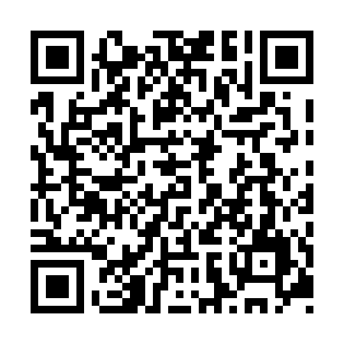

**Ramadan times for Marsh Lake, Yukon, Canada**

**Fri 28 Feb 2025 - Sun 30 Mar 2025**

**High Latitude Method: Angle Based Rule**

**Prayer Calculation Method: Islamic Society of North America**

**Asar Calculation Method: Hanafi**

|  |  |  |  |  |  |  |  |  |  |
| --- | --- | --- | --- | --- | --- | --- | --- | --- | --- |
| **Date** | **Day** | **Fajr** | **Suhur** | **Sunrise** | **Dhuhr** | **Asr** | **Iftar** | **Maghrib** | **Isha** |
| 28 | Fri | 6:02 | 6:02 | 7:58 | 1:10 | 4:18 | 6:23 | 6:23 | 8:19 |
| 1 | Sat | 5:59 | 5:59 | 7:55 | 1:10 | 4:20 | 6:25 | 6:25 | 8:21 |
| 2 | Sun | 5:56 | 5:56 | 7:52 | 1:09 | 4:22 | 6:28 | 6:28 | 8:24 |
| 3 | Mon | 5:53 | 5:53 | 7:49 | 1:09 | 4:25 | 6:30 | 6:30 | 8:26 |
| 4 | Tue | 5:50 | 5:50 | 7:46 | 1:09 | 4:27 | 6:33 | 6:33 | 8:29 |
| 5 | Wed | 5:47 | 5:47 | 7:43 | 1:09 | 4:29 | 6:36 | 6:36 | 8:32 |
| 6 | Thu | 5:44 | 5:44 | 7:40 | 1:08 | 4:31 | 6:38 | 6:38 | 8:34 |
| 7 | Fri | 5:41 | 5:41 | 7:37 | 1:08 | 4:33 | 6:41 | 6:41 | 8:37 |
| 8 | Sat | 5:38 | 5:38 | 7:34 | 1:08 | 4:35 | 6:43 | 6:43 | 8:40 |
| 9 | Sun | 6:35 | 6:35 | 8:31 | 2:08 | 5:38 | 7:46 | 7:46 | 9:42 |
| 10 | Mon | 6:31 | 6:31 | 8:28 | 2:07 | 5:40 | 7:48 | 7:48 | 9:45 |
| 11 | Tue | 6:28 | 6:28 | 8:25 | 2:07 | 5:42 | 7:51 | 7:51 | 9:48 |
| 12 | Wed | 6:25 | 6:25 | 8:22 | 2:07 | 5:44 | 7:53 | 7:53 | 9:51 |
| 13 | Thu | 6:21 | 6:21 | 8:19 | 2:07 | 5:46 | 7:56 | 7:56 | 9:54 |
| 14 | Fri | 6:18 | 6:18 | 8:16 | 2:06 | 5:48 | 7:58 | 7:58 | 9:56 |
| 15 | Sat | 6:15 | 6:15 | 8:13 | 2:06 | 5:50 | 8:01 | 8:01 | 9:59 |
| 16 | Sun | 6:11 | 6:11 | 8:10 | 2:06 | 5:52 | 8:03 | 8:03 | 10:02 |
| 17 | Mon | 6:08 | 6:08 | 8:06 | 2:05 | 5:54 | 8:06 | 8:06 | 10:05 |
| 18 | Tue | 6:04 | 6:04 | 8:03 | 2:05 | 5:56 | 8:08 | 8:08 | 10:08 |
| 19 | Wed | 6:01 | 6:01 | 8:00 | 2:05 | 5:58 | 8:11 | 8:11 | 10:11 |
| 20 | Thu | 5:57 | 5:57 | 7:57 | 2:05 | 6:00 | 8:13 | 8:13 | 10:14 |
| 21 | Fri | 5:53 | 5:53 | 7:54 | 2:04 | 6:02 | 8:16 | 8:16 | 10:17 |
| 22 | Sat | 5:50 | 5:50 | 7:51 | 2:04 | 6:04 | 8:18 | 8:18 | 10:20 |
| 23 | Sun | 5:46 | 5:46 | 7:48 | 2:04 | 6:06 | 8:21 | 8:21 | 10:23 |
| 24 | Mon | 5:42 | 5:42 | 7:45 | 2:03 | 6:08 | 8:23 | 8:23 | 10:26 |
| 25 | Tue | 5:39 | 5:39 | 7:42 | 2:03 | 6:10 | 8:26 | 8:26 | 10:29 |
| 26 | Wed | 5:35 | 5:35 | 7:39 | 2:03 | 6:12 | 8:28 | 8:28 | 10:33 |
| 27 | Thu | 5:31 | 5:31 | 7:36 | 2:03 | 6:14 | 8:31 | 8:31 | 10:36 |
| 28 | Fri | 5:27 | 5:27 | 7:32 | 2:02 | 6:16 | 8:33 | 8:33 | 10:39 |
| 29 | Sat | 5:23 | 5:23 | 7:29 | 2:02 | 6:18 | 8:36 | 8:36 | 10:43 |
| 30 | Sun | 5:19 | 5:19 | 7:26 | 2:02 | 6:19 | 8:38 | 8:38 | 10:46 |

**Prayer times provided by https://www.salahtimes.com**