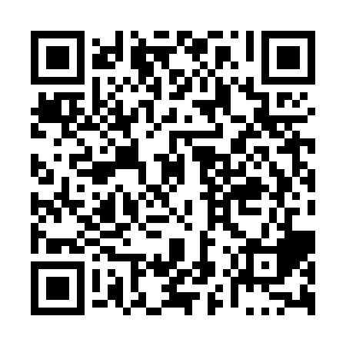

**Ramadan times for Toniata, Manitoba, Canada**

**Fri 28 Feb 2025 - Sun 30 Mar 2025**

**High Latitude Method: Angle Based Rule**

**Prayer Calculation Method: Islamic Society of North America**

**Asar Calculation Method: Hanafi**

|  |  |  |  |  |  |  |  |  |  |
| --- | --- | --- | --- | --- | --- | --- | --- | --- | --- |
| **Date** | **Day** | **Fajr** | **Suhur** | **Sunrise** | **Dhuhr** | **Asr** | **Iftar** | **Maghrib** | **Isha** |
| 28 | Fri | 5:37 | 5:37 | 7:05 | 12:33 | 4:11 | 6:02 | 6:02 | 7:31 |
| 1 | Sat | 5:35 | 5:35 | 7:03 | 12:33 | 4:13 | 6:04 | 6:04 | 7:32 |
| 2 | Sun | 5:33 | 5:33 | 7:01 | 12:33 | 4:14 | 6:06 | 6:06 | 7:34 |
| 3 | Mon | 5:31 | 5:31 | 6:59 | 12:33 | 4:16 | 6:07 | 6:07 | 7:35 |
| 4 | Tue | 5:29 | 5:29 | 6:57 | 12:33 | 4:17 | 6:09 | 6:09 | 7:37 |
| 5 | Wed | 5:27 | 5:27 | 6:55 | 12:32 | 4:19 | 6:11 | 6:11 | 7:39 |
| 6 | Thu | 5:25 | 5:25 | 6:53 | 12:32 | 4:20 | 6:12 | 6:12 | 7:40 |
| 7 | Fri | 5:23 | 5:23 | 6:51 | 12:32 | 4:21 | 6:14 | 6:14 | 7:42 |
| 8 | Sat | 5:21 | 5:21 | 6:49 | 12:32 | 4:23 | 6:15 | 6:15 | 7:44 |
| 9 | Sun | 6:18 | 6:18 | 7:46 | 1:31 | 5:24 | 7:17 | 7:17 | 8:45 |
| 10 | Mon | 6:16 | 6:16 | 7:44 | 1:31 | 5:25 | 7:19 | 7:19 | 8:47 |
| 11 | Tue | 6:14 | 6:14 | 7:42 | 1:31 | 5:27 | 7:20 | 7:20 | 8:49 |
| 12 | Wed | 6:12 | 6:12 | 7:40 | 1:31 | 5:28 | 7:22 | 7:22 | 8:50 |
| 13 | Thu | 6:10 | 6:10 | 7:38 | 1:30 | 5:29 | 7:23 | 7:23 | 8:52 |
| 14 | Fri | 6:07 | 6:07 | 7:36 | 1:30 | 5:31 | 7:25 | 7:25 | 8:54 |
| 15 | Sat | 6:05 | 6:05 | 7:34 | 1:30 | 5:32 | 7:27 | 7:27 | 8:55 |
| 16 | Sun | 6:03 | 6:03 | 7:32 | 1:29 | 5:33 | 7:28 | 7:28 | 8:57 |
| 17 | Mon | 6:01 | 6:01 | 7:29 | 1:29 | 5:35 | 7:30 | 7:30 | 8:59 |
| 18 | Tue | 5:58 | 5:58 | 7:27 | 1:29 | 5:36 | 7:31 | 7:31 | 9:00 |
| 19 | Wed | 5:56 | 5:56 | 7:25 | 1:29 | 5:37 | 7:33 | 7:33 | 9:02 |
| 20 | Thu | 5:54 | 5:54 | 7:23 | 1:28 | 5:38 | 7:35 | 7:35 | 9:04 |
| 21 | Fri | 5:51 | 5:51 | 7:21 | 1:28 | 5:40 | 7:36 | 7:36 | 9:06 |
| 22 | Sat | 5:49 | 5:49 | 7:19 | 1:28 | 5:41 | 7:38 | 7:38 | 9:07 |
| 23 | Sun | 5:47 | 5:47 | 7:16 | 1:27 | 5:42 | 7:39 | 7:39 | 9:09 |
| 24 | Mon | 5:44 | 5:44 | 7:14 | 1:27 | 5:43 | 7:41 | 7:41 | 9:11 |
| 25 | Tue | 5:42 | 5:42 | 7:12 | 1:27 | 5:44 | 7:42 | 7:42 | 9:13 |
| 26 | Wed | 5:40 | 5:40 | 7:10 | 1:26 | 5:46 | 7:44 | 7:44 | 9:15 |
| 27 | Thu | 5:37 | 5:37 | 7:08 | 1:26 | 5:47 | 7:45 | 7:45 | 9:16 |
| 28 | Fri | 5:35 | 5:35 | 7:06 | 1:26 | 5:48 | 7:47 | 7:47 | 9:18 |
| 29 | Sat | 5:32 | 5:32 | 7:03 | 1:26 | 5:49 | 7:49 | 7:49 | 9:20 |
| 30 | Sun | 5:30 | 5:30 | 7:01 | 1:25 | 5:50 | 7:50 | 7:50 | 9:22 |

**Prayer times provided by https://www.salahtimes.com**